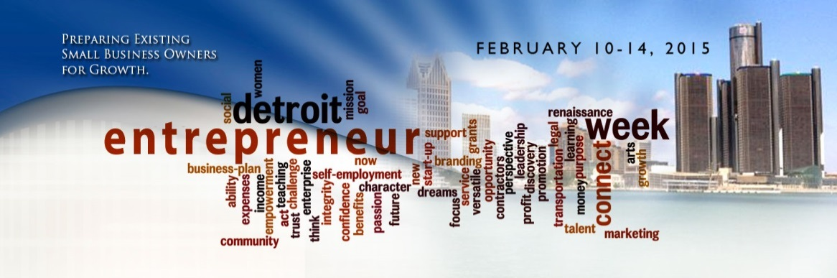
CONTACT:
Robin Kinnie
rkinnie@miceed.org

FOR IMMEDIATE RELEASE January 20, 2015

DETROIT COLLABORATIVE TO HOST 2015 “DETROIT ENTREPRENEUR WEEK”
Five-day event geared towards existing businesses in operation for more than two years

Detroit — Small business owners are often overlooked for aspiring entrepreneurs. Why? It is assumed that they need more assistance and it’s easier to teach someone how to build a business plan than to identify why an existing business is not reaching monthly sales goals. In an effort to connect existing small business owners to available resources, a collaborative of resource providers has announced the 2015 “Detroit Entrepreneur Week”, scheduled for Feb. 10-14 at Focus: HOPE Center for Advanced Technologies, 1400 Oakman Blvd., Detroit. The Small Business Legal Academy organized by some of Detroit’s leading law firms and legal departments will be held at Wayne State University Law School, 471 W. Palmer, Detroit on Saturday, Feb. 14.

The Detroit Entrepreneur Week is a five-day, no-cost conference created to promote business growth and entrepreneurship in the city of Detroit. This event is specifically designed for businesses in operation for more than two years. Topics for engaging sessions, led by local influencers, range from neighborhood economic development initiatives to different approaches to financing your business. Weekday workshops will be held at 9:00am-12:00pm at Focus:HOPE. The Saturday Small Business Legal Academy will be held at the WSU Law School from 8:30am to 4:00 pm.

Detroit Entrepreneur Week is designed for businesses poised for growth with the intent of creating jobs. According to U.S. Small Business Administration, small businesses create 64 percent of new private-sector jobs. Additionally, 52 percent of small businesses are home-based and only half of all new businesses survive five years or more with 1/3 surviving the first 10 years.

Sponsors and Participating Organizations currently include Center For Empowerment and Economic Development (CEED), ProsperUS Detroit, SCORE Detroit, TechTown Detroit, Wayne Alumni Law Group and Wayne State University Law School Program for Entrepreneurship and Business Law (PEBL).

SESSION TOPICS AT A GLANCE:
- “Planning for Business Growth” panel - will include a range of business development resource providers leading the industry in connecting you to the resources you need for growth

- Interactive workshop for food businesses led by Foodlab Detroit

- Neighborhood and Economic Development panel of community-based organizations

- Sales and marketing workshops

- “Different Approaches to Lending” panel featuring a variety of financing options for small business owners.

The final day will feature an all-day Small Business Legal Academy held at Wayne State University Law School. All-day agenda includes panel discussions ranging from Intellectual Property, Marketing Issues and Funding Issues to information for social entrepreneurs and nonprofits. The day will also feature “Ask a Lawyer” sessions where participants can meet one-on-one with legal professionals representing different law firms across metro Detroit.

Online registration only at dew15.eventbrite.com

Statements of Support
“As a program, we are very supportive of neighborhood-based entrepreneur networks. This is a wonderful example of a way to integrate entrepreneurial support within neighborhood development.” Kimberly Faison, Director, ProsperUS Detroit

“Navigating Detroit’s entrepreneurial ecosystem can be a bit daunting for a busy entrepreneur,” said Leslie Smith, president and CEO of TechTown Detroit. “As a partner in Detroit Entrepreneur Week, we see a clear need to remove hurdles and connect entrepreneurs with our robust network of support resources. In many cases, this is the first step down the path to sustainable growth.”

“Having worked with CEED and TechTown Detroit and other organizations over the last several years, Wayne State University Program for Entrepreneurship and Business Law is honored to support another opportunity to build entrepreneurship within the community.” Eric C. Williams, Director of the Program for Entrepreneurship and Business Law and Assistant Professor, Wayne State University Law School.

“The Small Business Legal Academy will feature a number of lawyers from Detroit’s leading law firms and legal departments with panels discussing the legal and business concerns of early stage entrepreneurs. There are both organized panels and ample opportunities to meet with legal experts one on one to find the resources necessary to move your business ideas to the next level.” Thomas Linn, Chair Emeritus of Miller Canfield and coordinator of the Academy.

“There are numerous resources and events for start-ups and aspiring entrepreneurs,” said Robin Kinnie, Communications Manager, CEED. “We want to be part of the growth strategy for those businesses who are home-based, have hit a plateau or simply aren't aware of resources available for businesses already in operation”.

Additional workshops and speakers are still being scheduled. Keep up with the latest information and follow the event live by using #DEW15. For more information and to register, visit dew15.eventbrite.com.

ABOUT DETROIT ENTREPRENEUR WEEK
Detroit Entrepreneur Week is an annual event coordinated by a collaborative of small business resource providers. Last year, the event attracted more than 200 small business owners. Detroit Entrepreneur Week is focused on connecting small business owners to resources for growth.
#

